Flight Path: AI-Powered Assessment
and Personalized Recommendation

A System Plan Proposal Submitted to the Faculty
of the School of Computing and Information Technologies
Asia Pacific College, Makati City

In Partial Fulfillment of the Requirements of the subject
Introduction to Systems and Design for IT
SSYADD1

By
Justin Bryden G. Arroco | Don Victor L. Idos
John Michael O. Maala | Andrei Luis M. Torres
Adviser: Manuel L. Calimlim, Jr.
Consultant: Felino Calderon

I. Design Thinking

Stage 1 – Empathize:
Introduction
The first step of the design thinking process is to build empathy and develop a deep understanding of the people for whom we are designing the solution. For the “Flight Path” project, this meant engaging closely with the client, UpsWing!, to uncover their real needs, frustrations, and aspirations beyond what was written in initial project requirements. Our goal in this stage was not only to learn what they say they need, but also to understand what they do, think, and feel when navigating their current assessment process.
To accomplish this, our team conducted a series of interactions that served as in-depth client interviews. The first formal meeting was held through Google Meet with the UpsWing! CEO and representatives. During this session, we explored their current ESL assessment process, discussed its limitations, and aligned on the broader objectives of the project. The client emphasized recurring challenges such as inefficiency, reliance on manual evaluations, and scalability issues. They also stressed their commitment to academic rigor by referencing their use of CEFR standards, item analysis, and inter-rater reliability checks. This meeting set the foundation for understanding that the problem was not simply technical but also organizational and educational in nature.
Beyond the initial interview, our team also maintained direct chat conversations with the client. These discussions became a valuable channel for clarifying requirements, addressing changes, and confirming expectations in real time. This iterative exchange ensured that our understanding of the client’s pain points and goals remained aligned with their evolving needs.
Through these engagements, we not only documented the client’s processes but also began to empathize with the different personas involved: learners frustrated by slow placement, parents seeking clear reports before making payment decisions, tutors burdened by manual evaluations, and administrators struggling with operational bottlenecks. These insights highlighted the human side of the problem and provided the foundation for framing the root cause and defining what a successful solution should look like.

Client Interviews

To better understand the needs and challenges of the client, our team conducted a series of interviews and follow-up discussions with UpsWing!’s CEO and representatives. These interactions were carried out through both formal and informal channels, enabling us to gain a holistic perspective of the current ESL assessment process.
The first formal interview took place via Google Meet. This session allowed us to explore the existing placement and diagnostic system in detail. The client explained that their current process relies heavily on coordinators and admins, which makes it time-consuming, inconsistent, and difficult to scale as enrollment grows. They emphasized that while efficiency is important, the solution must also uphold academic rigor, citing their reliance on CEFR standards, item analysis, and inter-rater reliability checks to maintain validity.
In addition to the formal meeting, we also engaged in direct chat conversations with the client through messaging platforms. These follow-up discussions were crucial for clarifying requirements, confirming project scope, and addressing updates or changes the client wanted to make as the project progressed. These exchanges gave us real-time insights into their expectations, such as the importance of distinguishing between adaptive placement tests and non-adaptive diagnostic tests, and their interest in integrating AI-driven speaking assessments.
From these interviews, several recurring themes emerged:
- Inefficiency: Current manual processes delay student evaluation and learning path assignment, frustrating students.
- Scalability issues: Reliance on admins and tutors creates bottlenecks as student numbers grow.
- Consistency and rigor: The system must ensure reliable, CEFR-aligned assessment results.
- Stakeholder impact: Tutors and admins face heavy workloads, while students risk mismatched placements.

FIGURE I: ONLINE GOOGLE MEET MEETING WITH UPSWING!
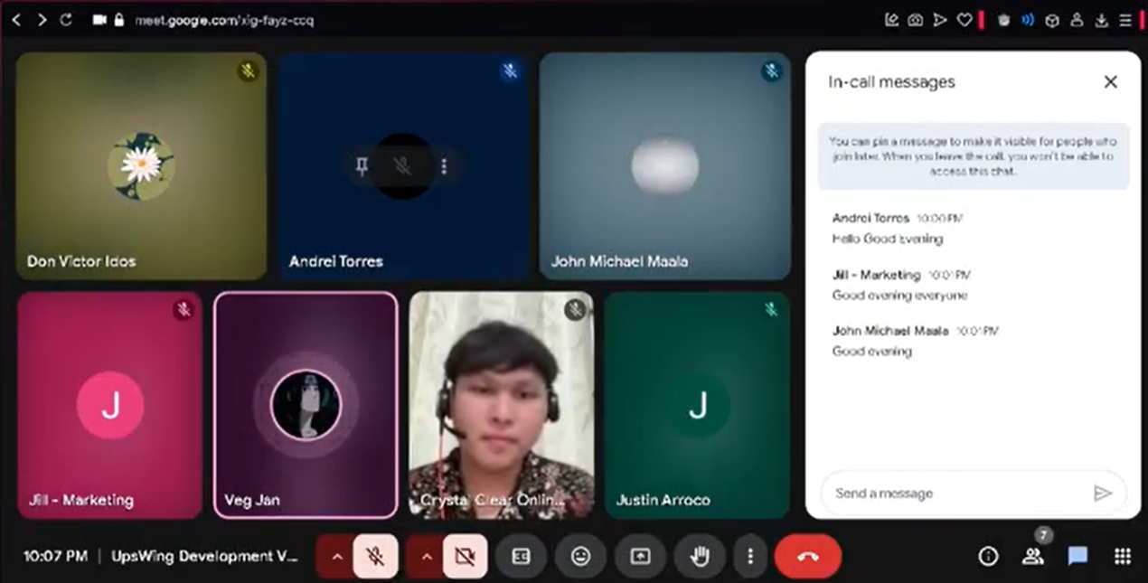

Identified Root Cause Analysis
Analyzing the client’s statements revealed the underlying cause driving this project.

Problem: UpsWing! needs to automate its assessment process.
- Why #1? The process is slow.
- Why #2? Because it is done manually.
- Why #3? Because admins must handle each assessment by hand, and they cannot keep up with the number of new requests.
- Why #4? (Root Cause) Because there is no existing automated system in place to support or replace the manual work.

Identified Customer Personas
FIGURE II: Empathy Map
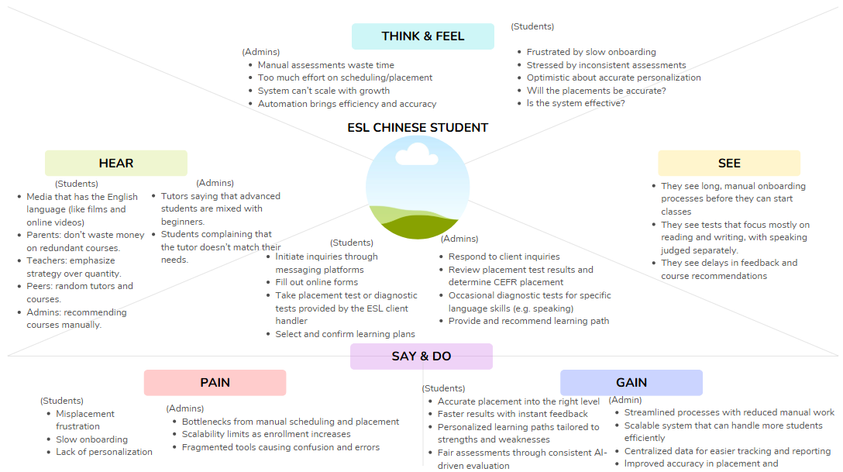

The interviews and discussions also highlighted the following key user groups whose needs and pains must be addressed:
- Students – The end-user who takes the tests. Their experience is central to the project’s goal of improving operational efficiency and accuracy. A fast, accurate assessment process is essential to their motivation and success.
- Admins – An internal user responsible for managing assessment workflows. Their pain points include repetitive manual tasks, bottlenecks, and coordination issues that slow down operations.
- Tutors – Another internal user who plays a role in reviewing students' performance and conducting trial classes. Their involvement in manual evaluation represents a significant labor cost and introduces subjectivity that the new system aims to minimize.

Key Open-Ended Questions
- What is the core problem with the current system?
Answer: The current system is manual, labor-intensive, and inconsistent It is too slow to scale with growing demand and often fails to consistently assess students, leading to frustration and misaligned learning path.
- What does a successful solution look like?
Answer: Success is an automated system that delivers computerized adaptive testing (CAT) for placement assessment and combined with AI-based diagnostic assessments for speaking and writing, in which ultimately outputs comprehensive recommendation feedback based on those assessments. This system should provide instant, accurate, CEFR-aligned results that guide learners into personalized learning paths.
- What are the most important constraints and requirements?
Answer: The solution must function as a backend system that can integrate into the client’s existing platform. It must clearly distinguish between adaptive placement tests and non-adaptive diagnostic tests, as this distinction is critical to the client’s process.

Q&A Session with Client – UpsWing!
This session took place in a discord conversation.

Format: Q&A for Clarifications
- Q1. How is the accuracy of assessment tests usually evaluated in the company’s processes? What frameworks (e.g., CEFR, IELTS standards) are you aligning with?
A1. UpsWing evaluates accuracy through CEFR-aligned diagnostic rubrics across listening, speaking, reading, and writing (Pre-A1 to C2). Tests may also include IELTS-style tasks for comparability. Accuracy is ensured by:
- Conducting item analysis (difficulty index, distractor effectiveness)
- Performing inter-rater reliability checks for speaking/writing rubrics
- Running pilot assessments before rollout
- Aligning benchmarks with CEFR Companion Volume and academic references (Cambridge, ALTE, etc.)

- Q2. Is the system expected to have a “user feedback” functionality?
A2. Yes. Feedback is integrated at multiple levels, including:
- Tutor feedback forms after every class
- Parent reaction buttons on lesson reports
- Monthly parent satisfaction check-ins (via WeChat/LINE/email)
- AI sentiment analysis on open-ended feedback
- Automatic flagging of low scores for review

- Q3. Will there be formal surveys, interviews, or usage analytics?
A3. Yes. UpsWing applies triangulated feedback methods:
- Quarterly, pathway-based surveys for parents, learners, and tutors
- 1-on-1 interviews with parents/tutors (by HR or DSSI)
- Platform analytics (attendance rates, completion rates, reschedule frequency, dashboard engagement)
- Churn risk scoring from engagement/feedback data

- Q4. What is the current step-by-step ESL process at UpsWing!?
A4.
- Client Inquiry Handling – Contact via Messenger, WeChat, LINE, or website → Coordinator responds, explains program → Learner fills out online form → Briefing on diagnostic test.
- Placement Test & Analysis – Learner completes LMS diagnostic test → CEFR level evaluated → Academic team drafts recommendation.
- Trial Class Scheduling – Coordinator arranges 25-min trial → Materials sent via LMS → Tutor briefed.
- Trial Class Execution – Tutor conducts session → Learner participates in speaking activities → Tutor submits evaluation.
- Level Recommendation & Enrollment – Academic team finalizes CEFR placement → Parent selects plan/payment → Learner assigned tutor → Schedule confirmed.
- Class Delivery – Regular ClassIn sessions → Tutor uses LMS materials → Homework + AI-reviewed tasks.
- Feedback & Reporting – Tutor submits post-class feedback → Progress tracked in LMS → Monthly bilingual reports sent to parents.

- Q5. How will speaking and writing assessments work?
A5.
- Pronunciation Test: Students read aloud sentences/paragraphs. Evaluates clarity, stress, intonation, vowel/consonant accuracy.
- Speaking Test: Topic prompts/role-play. Evaluates fluency, coherence, vocabulary, grammar, communicative effectiveness.
- Writing Test: Constructed responses (reports, reflections). Evaluated with AI scoring aligned to CEFR rubrics.

- Q8. Which tests will be adaptive vs. non-adaptive?
A8.
- Placement Assessment: Adaptive (CAT) – used to determine CEFR level and general English skills.
- Diagnostic Assessment: Non-adaptive – focused on specific skill gaps after courses/lessons. Includes speaking/writing AI evaluations and non-adaptive multiple-choice for reading/listening.
- Summary: Placement = adaptive CEFR test. Diagnostics = non-adaptive gap analysis.

Insights Summary
The empathize stage confirmed that UpsWing!’s challenge goes beyond inefficiency; the deeper issue is that manual and inconsistent assessment processes lead to inaccurate placement, which in turn causes poor student engagement, dissatisfaction, and eventual churn. While efficiency and scalability are pressing business needs, the client emphasized that any solution must also preserve academic rigor and CEFR alignment to maintain credibility and learner trust.
Through client interviews, root cause analysis, and persona identification, we gained a clearer view of the needs of learners, parents, tutors, and administrators. Each group experiences the shortcomings of the current system differently, but all are connected by the need for a faster, more accurate, and scalable placement process.
These insights provide a strong foundation for the next stage of the design thinking process—Define—where we will synthesize the findings into a clear problem statement and identify opportunities for innovation.

Project Charter

Flight Path: AI-Powered Assessment and Personalized Recommendation
Purpose:
The Flight Path project was created to modernize and improve the English as a Second Language (ESL) assessment process at UpsWing!, an ESL education provider. Currently, their processes rely on time-consuming, manual evaluations that often result in inconsistent assessment decisions. Our goal is to solve these problems by introducing an AI-powered assessment system with AI-powered adaptive and diagnostic testing capability and personalized learning path recommendations. This will ensure that their onboarding and evaluation processes are faster, more accurate skill profiling, and tailored learning experiences that align with each learner’s goals and proficiency level.

High-level project description
Flight Path is a modular backend system designed for integration with UpsWing!’s existing platform. It will include the ff:
- Assessment Module that are adaptive and non-adaptive. The adaptive tests will be based on psychometric models such as MIRT, for precise CEFR-aligned placement and non-adaptive tests will include more specific language skill evaluation such as speaking and writing assessments.
- Recommendation Engine that generates personalized learning paths based on the evaluation results.
- Administrative Tools for managing item banks, exporting reports, and monitoring assessment performance.
This system will be API-ready, allowing seamless integration with UpsWing!’s system while maintaining flexibility for future expansion.

High-level milestone schedule

TABLE I: HIGH-LEVEL MILESTONE SCHEDULE
Milestone | Estimated Week
Started Project Planning and Discovery, and Gathering of High-level Client Requirements | Apr 28 – May 11
User Research & Problem Definition Completed | May 12 – Jul 13
Finalization of Overall Project Requirements and Planning | Aug 4 – Aug 24
Finalization of System Architecture and API specs | Sep 8 – Sep 21
Development of Adaptive Test (includes prototype demonstration and iterative feedback gathering) | Sep 22 – Oct 26
Development of Non-Adaptive Diagnostic Tests for Specific Language Skills Evaluation (includes prototype demonstration and iterative feedback gathering) | Oct 27 – Nov 16
Implementation of Recommendation Engine (includes prototype demonstration and iterative feedback gathering) | Nov 17 – Dec 7
API Development of the Whole Backend module | Dec 7 – Jan 11
Internal Testing and Quality Assurance | Jan 12 - 18
Pilot Testing with Upswing Client | Jan 19 – Jan 25
Finalize Feedback Gathering and System Refinement | Jan 26 – Feb 8
Final Testing, Optimization, and Documentation | Feb 9 – Feb 14
Final Delivery and Project Closure | Feb 15 – Feb 25

Rough cost estimate
The total estimate is ₱102,200.00. This comprehensive budget is allocated to cover all anticipated expenses required to meet the project objectives, including labor, materials, and administrative overhead.
The budget is broken down into two primary categories:
Planned Labor Costs: ₱61,000.00. This covers an estimated 610 hours of work by the four-person project team, based on a standard rate of ₱100/hour.
Planned Material & Unit Costs: ₱41,200.00. This includes all non-labor expenses such as co-working space fees, software subscriptions, supplies, and a contingency reserve.
The budget is strategically allocated across the project lifecycle, with most resources dedicated to the Executing phase.
- Initiation Phase – ₱23,000.00
- Planning Phase – ₱24,000.00
- Executing Phase – ₱41,200.00
- Monitoring & Controlling Phase – ₱8,500.00
- Closing Phase – ₱5,500.00

Stakeholders
- Upswing! (Client / Organization) – Provides budget, approves major decisions, sets priorities and requirements, gives feedback and recommendations.
- Manuel L. Calimlim (Project Adviser) – Provides academic supervision and general project guidance.
- Felino Calderon (Project Consultant) – Guides technical implementation, design choices, and overall project recommendations.
- Tutors (Upswing ESL Tutors) – End users who provide feedback on CEFR placement accuracy and diagnostic fairness.
- Students (Upswing ESL Students) – Primary end users; provide feedback on learning path recommendations and fairness of placement results.
- W.A.S.D (Development Team, APC) – Core builders of the FlightPath system; ensure functionality meets academic and client standards.
- Admins (Upswing Academic/Operations Department) – Use diagnostic and placement tools, review results, and provide ongoing feedback.
- Instructor and School (Asia Pacific College, PBL Program) – Oversee project progress, academic compliance, and documentation quality.
- Testers – Evaluate usability, provide performance feedback, and verify system stability before deployment.

Project manager: Andrei Luis M. Torres, Project Leader
Project manager’s responsibilities:
- Oversee overall project coordination and lead team efforts.
- Ensure all documentation, written materials and deliverables are comprehensive and meet quality standards.
- Communicate with the project adviser on behalf of the team.
- Make sure the project is on track with the timeline.

Project manager’s authority
- Lead project meetings and presentations to the client and adviser.
- Assign tasks to the dev team members.
- Guide the project workflow
- Manage which tasks to be prioritized
- Make final decisions with team input

Formal declaration of sponsor’s support
Sponsor Name: Jose Eugenio L. Quesada
Position: Project-Based Learning Instructor

Support Statement:
As the instructor for the Project-Based Learning course, I support the FlightPath: AI-Powered Assessment and Personalized Recommendation project created by the student group. This project has the potential to modernize and improve the English as a Second Language (ESL) assessment and placement process for educational providers. It clearly demonstrates the students' ability to solve real-world problems through technology by addressing the inefficiencies of traditional evaluation methods. I encourage the group to complete this project with teamwork, effort, and creativity.

"Flight Path" Project Objectives
Primary Objective
Develop a modular, AI-assisted English language assessment and recommendation system to automate proficiency testing and generate personalized learning paths.

Specific Objectives
- Design and deploy an adaptive English assessment system within 6 months, achieving at least 90% accuracy in classifying learners according to CEFR levels.
- Integrate an AI-powered speaking assessment module that transcribes and scores learner responses, reducing manual evaluation time by at least 70%.
- Implement a data-driven recommendation engine within 4 months of system deployment, achieving at least 85% alignment with expert-curated recommendations.
- Deliver modular backend components, including the Adaptive Assessment Module, AI-Powered Speaking Assessment Module, Learner Recommendation Engine, and Administrative Utilities.

TABLE II: CATEGORIZED OBJECTIVE TABLE
Objective |  | Measure
  Category
To design and deploy a modular, AI-assisted English language assessment and recommendation system for UpsWing! | Development | Delivery of modular backend components for an Adaptive Assessment Module, AI-Powered Speaking Assessment Module, Learner Recommendation Engine, and Administrative Utilities.
To design and deploy an adaptive English assessment system with at least 90% accuracy in classifying learners according to CEFR proficiency levels. | Accuracy | The system’s classification accuracy will be verified against expert validation and must be at least 90%.
To integrate an AI-powered speaking assessment module that reduces manual evaluation time by at least 70%. | Efficiency
  The reduction in time for manual evaluation will be measured after the module’s integration and must be at least 70%.
To develop a data-driven recommendation engine that achieves at least 85% alignment with expert-curated recommendations. | Performance | Alignment with expert recommendations will be measured during pilot testing and must be at least 85%.
To develop a system that leverages psychometric models, transcribes and scores responses, and generates personalized learning paths. | Functionality
  The system must include the core logic for a Computerized Adaptive Testing (CAT) system, AI-driven speaking assessment using APIs, and a recommendation engine.

Scope Statement
Project Goal and Objectives
The goal of the project is to develop a modular, AI-assisted English language assessment and recommendation system for UpsWing!. The system will automate proficiency testing and create personalized learning paths by accurately evaluating a learner’s skills.

Project Boundaries
Within scope: The project includes the research, design, and development of reusable, modular backend components. The deliverables will be API-ready or plug-in compatible for UpsWing!’s existing platform. It includes:
- Adaptive Assessment Module
- AI-Powered Speaking Assessment Module
- Learner Recommendation Engine
- Standard Setting and CEFR Alignment Tools
- Administrative Support Utilities

Out of scope: The project does not include integration of the developed modules into the client’s existing UI/UX, front-end, or data flows. This responsibility falls to the client-side developers. The project is limited to English assessments only and does not support multilingual handling. Front-end elements, UI components, and visualization of results are excluded.
Project Deliverables
  - Adaptive Assessment Module
  - AI-Powered Speaking Assessment Module
  - Learner Recommendation Engine
  - Standard Setting and CEFR Alignment Tools
  - Administrative Support Utilities
Success Criteria
  - The adaptive English assessment system will be designed and deployed within 6 months, using psychometric models to classify learners according to CEFR proficiency levels with at least 90% accuracy.
  - The AI-powered speaking assessment module will be integrated by the end of the development phase, transcribing and scoring responses with at least a 70% reduction in manual evaluation time.
  - The recommendation engine will be implemented within 4 months of the assessment system’s deployment, producing personalized learning paths with at least 85% alignment to expert-curated recommendations during pilot testing.

Project Assumptions
- A demo item bank will be delivered, but full calibration using real learner data must be completed by the client.
- Accuracy and performance of the speech evaluation module depend on the reliability of external APIs.
Project Constraints
- Reliance on third-party APIs for speech evaluation.
- Exclusion of multilingual support.
- Exclusion of front-end/UI development.
- Integration into the client’s existing system is the responsibility of the client-side developers.

Stakeholder Analysis

TABLE III: STAKEHOLDER ANALYSIS TABLE
Name | Department/Company | Position | Advisers | Objective, Requirements, Interests | Influence | Project Contribution | Resitance
Upswings | ESL Company | Organization/Client |  |  | High | Provides budget, approves major decisions, sets priorities and requirements, feedbacks and recommendations, and overall project information. | Concerns about scope and budget.
  Ensure project meets organizational goals and product quality.
Manuel L. Calimlim  Jr. | Asia Pacific College | Project Adviser |  | Ensure project meets organizational goals and product quality. | High | Provides supervision and academic guidance, and general project recommendations. | Concerns about overall project quality.
Felino Calderon | Asia Pacific College | Project Consultant |  | Ensures project meets technical requirements and scope. | High | Guides technical implementation and design choices, and general project recommendations. | Concerns about overall project quality.
Tutors | Upswing | ESL Tutors | Upswing Academic Department | Requires fair and accurate CEFR placement and clear diagnostic feedback that aligns with course preparation. | Medium |  | Concerns about system accuracy and fairness.
  End users, and provides feedback.
Students | Upswing | ESL Students |  |  | High |  | Concerns about their overall student experience including fairness and appropriateness of recommended learning paths.
  Requires fair and accurate CEFR placement and diagnostic feedback, and receive appropriate learning path recommendations.
  End users, and provides feedback.
WASD | Asia Pacific College | Development Team | Project Adviser, Project Consultant | Deliver a functional FlightPath system that meets project requirements, satisfies client needs, and aligns with academic standards. | High | Core builders of the system (FlightPath). | Time/resource constraints, project technicality, achievable project goals.
Admins | Upswing | Academic/Operation Department |  | Requires accurate placement and diagnostic results, and appropriate learning path recommendations. | High | End users, and provides feedbacks. | Inaccurate assessment system and recommendation engine.

Tech Stack
Backend & Framework
- Programming Language: Python 3.11
- Web Framework: FastAPI
- ASGI Server: Uvicorn
Database & Data Management
- Database: MySQL 8
- ORM: SQLAlchemy (async)
- Schema Migrations: Alembic
- Configuration: dotenv (for environment variables)
AI, Data Science, & Core Libraries
- AI Engine (Core): MirtCAT (Multidimensional Item Response Theory Computerized Adaptive Testing) engine
- AI Service API: Gemini API (for speech-to-text, writing evaluation, and NLP)
- Numerical Libraries:
  - NumPy
  - SciPy
- Data Analysis: Pandas
DevOps & Tools
- Containerization: Docker and Docker Compose
- Version Control: GitHub
- API Testing & Documentation:
  - Postman
  - Swagger Docs / Swagger UI

IV. Diagrams

FIGURE III: USE CASE DIAGRAM
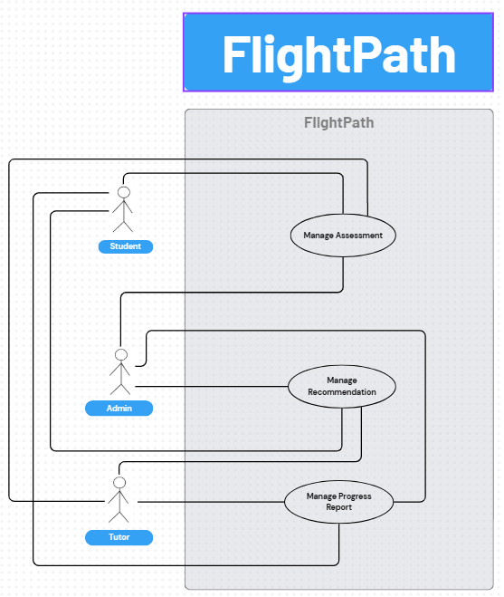

TABLE IV: TEST CASE TABLE
Test Case ID | Use Case ID | Test Case Name | Test Case Description
TC-01 | UC-01 | Admin Creates Valid Assessment (Basic Flow) | Verify the Admin can successfully create a new assessment by providing all valid parameters and item IDs.
TC-02 | UC-01 | Admin Creates New Item During Assessment Creation (Alt Flow) | Verify the Admin can successfully create a new item via the alternative flow, save it to the bank, and use its ID in the new assessment.
TC-03 | UC-01 | Admin Cancels Assessment Creation (Alt Flow) | Verify that if the Admin invokes the "Cancel" operation, the assessment data is not saved.
TC-04 | UC-01 | Admin Creates Assessment with Missing Data (Exception) | Verify the system outputs a validation error and does not save if the Admin tries to create an assessment with missing required parameters.
TC-05 | UC-02 | Admin Assigns Assessment to Single Student (Basic Flow) | Verify the Admin can provide an assessment ID and a single student ID to successfully confirm the assignment.
TC-06 | UC-02 | Admin Assigns Assessment to Group (Basic Flow) | Verify the Admin can provide an assessment ID and a student group ID to successfully confirm the assignment to all students in that group.
TC-07 | UC-02 | Admin Assigns When No Assessments Exist (Exception) | Verify the system outputs an appropriate error message if the Admin tries to assign an assessment but no active assessments are available.
TC-08 | UC-02 | Admin Assigns to Non-Existent Student (Exception) | Verify the system outputs an error if the Admin attempts to assign an assessment to a student ID that does not exist.
TC-09 | UC-03 | Student Completes Placement Assessment (Basic Flow) | Verify a Student can request and successfully complete a "Placement" assessment, and the results are stored.
TC-10 | UC-03 | Student Completes Writing Assessment (Basic Flow) | Verify a Student can request, complete, and submit the data for a "Writing" assessment, and the results are stored.
TC-11 | UC-03 | Student Completes Speaking Assessment (Basic Flow) | Verify a Student can request, provide answer data for, and submit a "Speaking" assessment, and the results are stored.
TC-12 | UC-03 | Admin Tests an Assessment (Basic Flow) | Verify an Admin can request and execute any assessment type to test/verify its functionality.
TC-13 | UC-03 | Student Exits Assessment Mid-Way (Alt Flow) | Verify that if a Student's session terminates mid-assessment, the system automatically saves their state.
TC-14 | UC-03 | Student Resumes Assessment (Alt Flow) | Verify a Student can re-initiate an assessment they exited mid-way and resume or restart it.
TC-15 | UC-03 | Student Re-records Speaking Answer (Alt Flow) | Verify a Student can invoke the re-record command during a "Speaking" assessment to replace a previous audio response before submission.
TC-16 | UC-03 | No Microphone Detected for Speaking Test (Exception) | Verify the system detects the absence of a working microphone (e.g., failed hardware check) and outputs an error when a Student starts a "Speaking" assessment.
TC-17 | UC-03 | Internet Failure During Submission (Exception) | Verify the system outputs an error message if the connection fails during the submission process.
TC-18 | UC-03 | Assessment Items Fail to Load (Exception) | Verify the system outputs an error message if the assessment items cannot be retrieved from the database.
TC-19 | UC-03 | Speaking/Writing Submission Fails (Exception) | Verify the system outputs an error message if the submission fails due to a file processing error or timeout.
TC-20 | UC-04 | Admin Edits Assessment Details (Basic Flow) | Verify an Admin can provide an existing assessment ID and modified parameters (e.g., title), and the changes are saved.
TC-21 | UC-04 | Admin Cancels Edit Assessment (Alt Flow) | Verify that if an Admin invokes the "Cancel" operation while editing, no changes are saved to the assessment.
TC-22 | UC-04 | Admin Edits Assessment with Invalid Data (Exception) | Verify the system outputs a validation error if the Admin tries to save invalid data in a modified parameter.
TC-23 | UC-04 | Admin Edits Assessment in Active Use (Exception) | Verify the system prevents an Admin from saving changes to an assessment that is actively in-progress by a student.
TC-24 | UC-04 | Admin Edits Non-Existent Assessment (Exception) | Verify the system outputs an error if the Admin attempts to edit an assessment ID that does not exist.
TC-25 | UC-05 | Admin Archives an Assessment (Basic Flow) | Verify an Admin can provide an assessment ID, invoke "Archive," and confirm the action, resulting in the assessment status being "Archived".
TC-26 | UC-05 | Admin Archives Assessment in Use (Exception) | Verify the system prevents an Admin from archiving an assessment that is currently assigned or in-use by students.
TC-27 | UC-06 | Student Reviews Own Assessment History (Basic Flow) | Verify a Student can request "Assessment History" and receive a list of their own completed assessments.
TC-28 | UC-06 | Student Filters Assessment History (Basic Flow) | Verify a Student can use filter and sort parameters in their history request, and the returned results are correct.
TC-29 | UC-06 | Admin Reviews Student's History (Alt Flow) | Verify an Admin/Tutor can request the assessment history for a specific student ID and receive that student's data.
TC-30 | UC-06 | User Reviews History for New Student (Exception) | Verify the system outputs a "No assessment history is found" message when requesting the history of a student who has none.
TC-31 | UC-07 | Student Exports Own Assessment History (Basic Flow) | Verify a Student can use filter parameters and invoke "Export" to generate and receive their own assessment history file.
TC-32 | UC-07 | Admin Exports Student's History (Alt Flow) | Verify an Admin/Tutor can request an export of a specific student's history and receive the correct file.
TC-33 | UC-07 | User Exports Empty History (Exception) | Verify the system outputs a "No history found" message if the user tries to export an empty history report.
TC-34 | UC-07 | Export File Generation Fails (Exception) | Verify the system outputs an error message if the file generation process fails on the server.
TC-35 | UC-07 | Export File Download Fails (Exception) | Verify the system outputs an error message if the file transmission fails.
TC-36 | UC-08 | Automatic Recommendation Generation (Basic Flow) | Verify that after a Student completes an assessment, the system automatically sends results and stores generated recommendations.
TC-37 | UC-08 | Admin Manually Triggers Recommendation (Alt Flow) | Verify an Admin can provide a student's assessment ID and manually trigger the "Generate Recommendations" process.
TC-38 | UC-08 | Recommendation Engine Fails (Exception) | Verify the system logs an error if the recommendation engine fails or times out during generation.
TC-39 | UC-08 | Recommendation from Corrupted Results (Exception) | Verify the system handles an error if the assessment results are missing or corrupted and cannot be analyzed.
TC-40 | UC-09 | Student Reviews Own Recommendations (Basic Flow) | Verify a Student can request the recommendations for a completed assessment and receive the associated data.
TC-41 | UC-09 | Admin Reviews Student's Recommendations (Alt Flow) | Verify an Admin/Tutor can request the recommendations for a specific student's assessment and receive the data.
TC-42 | UC-09 | User Reviews Non-Existent Recommendations (Exception) | Verify the system outputs a "No recommendations are found" message if the user requests recommendations that haven't been generated.
TC-43 | UC-10 | Admin Overrides Recommendation (Basic Flow) | Verify an Admin can provide a student's recommendation ID, invoke "Override," submit new items, and save the replacement.
TC-44 | UC-10 | Admin Overrides with Invalid Items (Exception) | Verify the system outputs an error if the Admin tries to save an override with item IDs that are invalid or non-existent.
TC-45 | UC-10 | Admin Saves Empty Override (Exception) | Verify the system outputs an error and does not save if the Admin attempts to save an empty recommendation list as an override.
TC-46 | UC-11 | Student Reviews Own Progress Report (Basic Flow) | Verify a Student can request "Progress Report" and receive their own analytics and trends.
TC-47 | UC-11 | Student Filters Progress Report (Basic Flow) | Verify a Student can use filter parameters in their progress report request, and the returned data is correct.
TC-48 | UC-11 | Admin Reviews Student's Progress Report (Alt Flow) | Verify an Admin/Tutor can request the real-time progress report for a specific student ID.
TC-49 | UC-11 | Analytics Generation Fails (Exception) | Verify the system outputs an error message if the analytics engine fails or times out.
TC-50 | UC-11 | User Reviews Report for New Student (Exception) | Verify the system outputs a "No data is found" message when trying to retrieve a report for a student with no assessment results.
TC-51 | UC-12 | Student Exports Own Progress Report (Basic Flow) | Verify a Student can request an export of their progress report, using filters, and successfully receive the file.
TC-52 | UC-12 | Admin Exports Student's Progress Report (Alt Flow) | Verify an Admin/Tutor can request an export of a specific student's progress report and receive the correct file.
TC-53 | UC-12 | Analytics Fail During Export (Exception) | Verify the system outputs an error if the analytics generation fails during the export process.
TC-54 | UC-12 | User Exports Report for New Student (Exception) | Verify the system outputs a "No data is found" error if attempting to export a report for a student with no data.
TC-55 | UC-12 | Export File Generation Fails (Exception) | Verify the system outputs an error message if the report file generation fails on the server.
TC-56 | UC-12 | Export File Download Fails (Exception) | Verify the system outputs an error message if the report file transmission fails.

FIGURE IV: DFD LEVEL 0
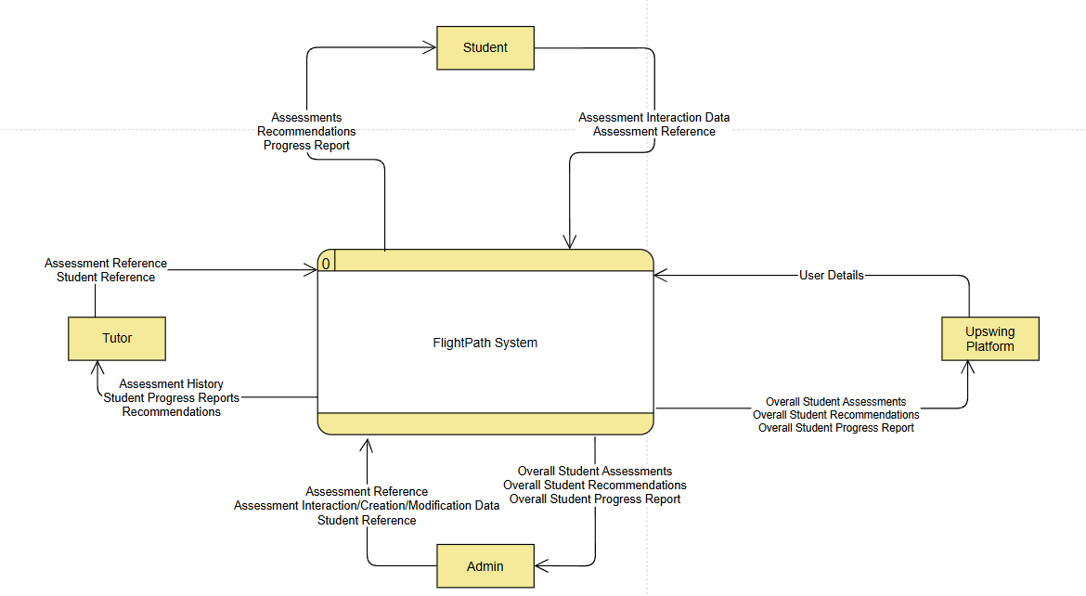
FIGURE V: DFD LEVEL 1
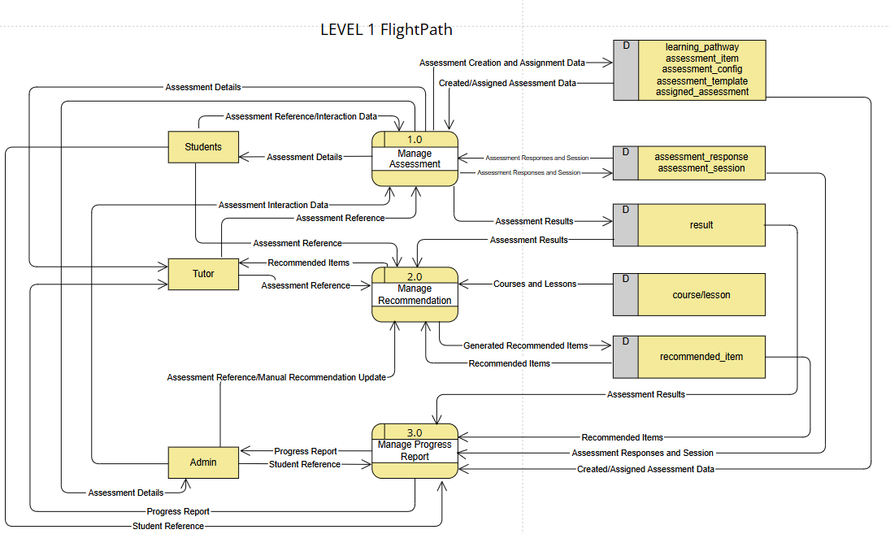

FIGURE VI: DFD LEVEL 2 – 1.0
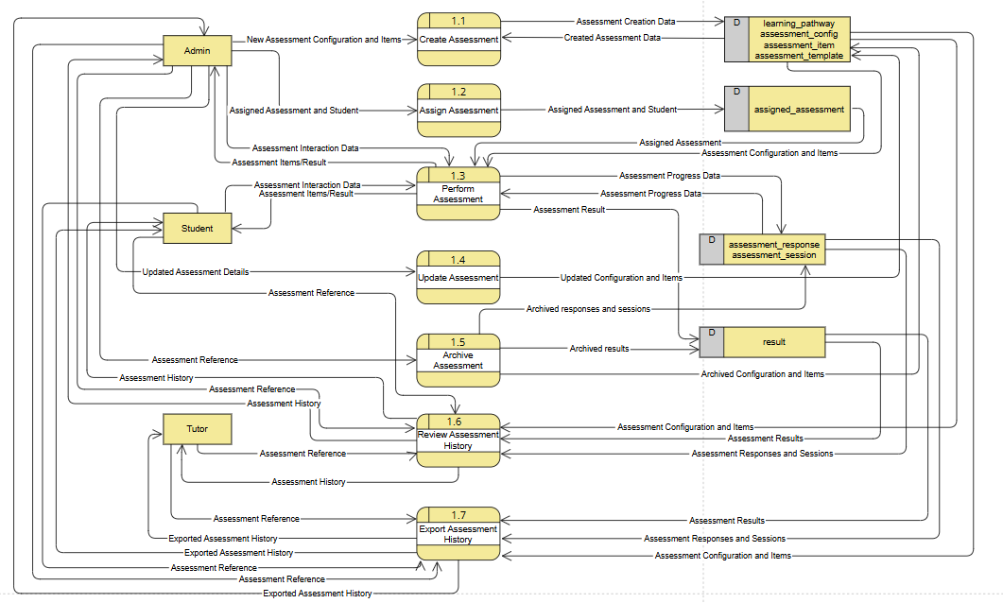
FIGURE VII: DFD LEVEL 2 – 2.0
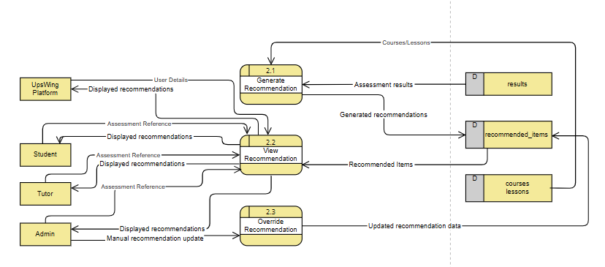

FIGURE VIII: DFD LEVEL 2 – 3.0
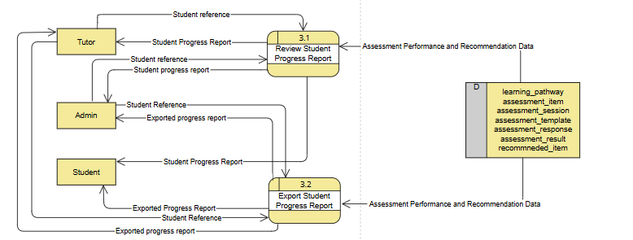

FIGURE IX: DFD LEVEL 3 – 1.3.x
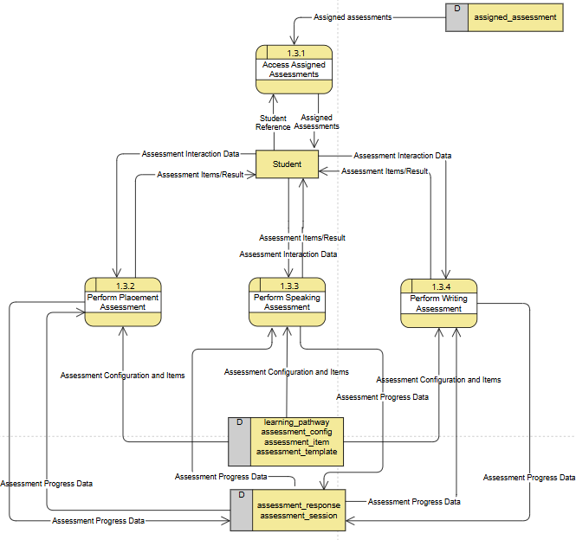

FIGURE X: DFD LEVEL 3 – 1.3.x
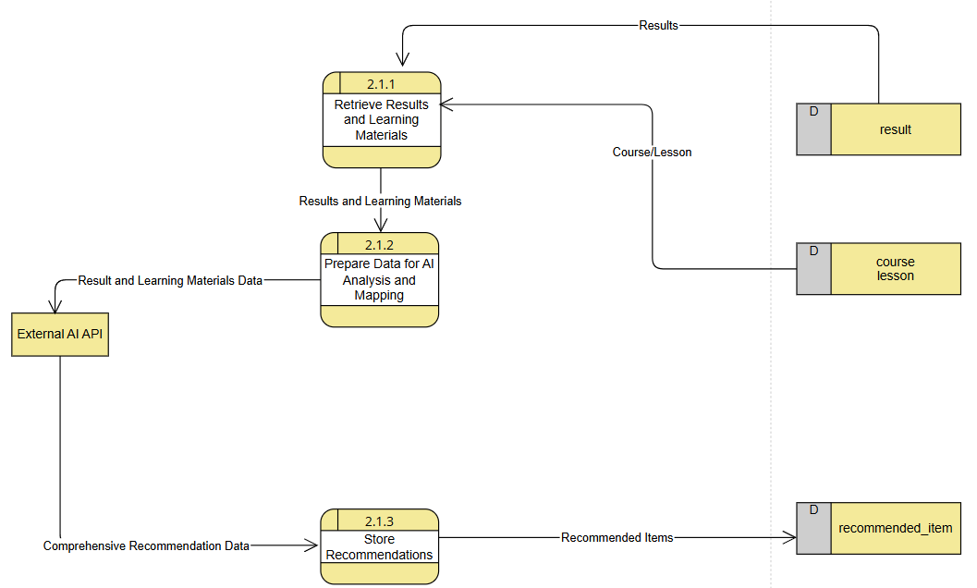

FIGURE XI: DFD LEVEL 4 – 1.3.2.x
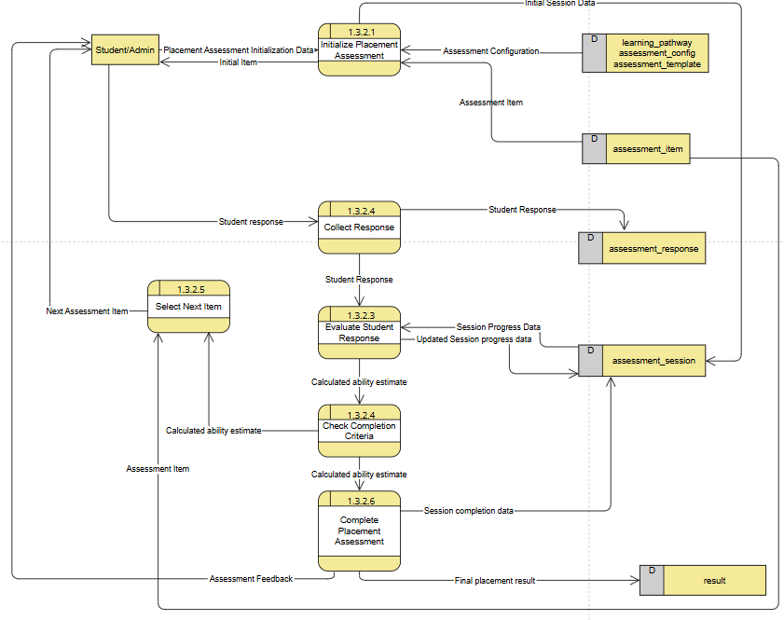

FIGURE XII: DFD LEVEL 4 – 1.3.3.x
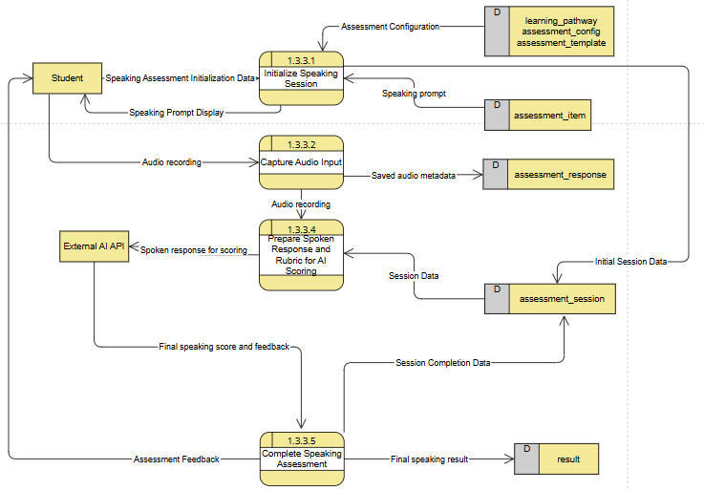

FIGURE XIII: DFD LEVEL 4 – 1.3.4.x
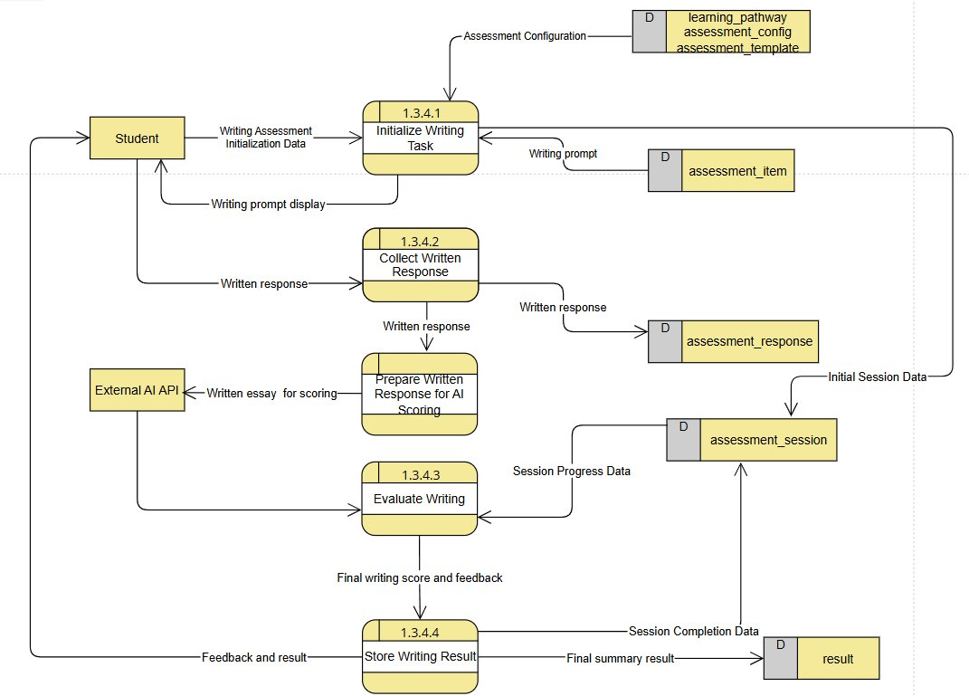

FIGURE XIV: ERD DIAGRAM
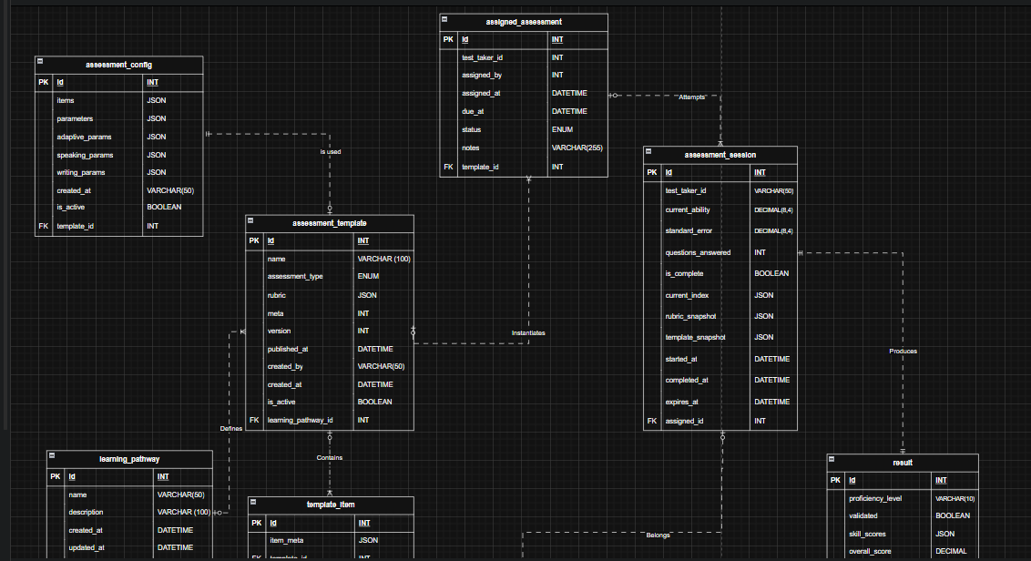
Link to ERD Diagram

FIGURE XV: ACTIVITY DIAGRAM
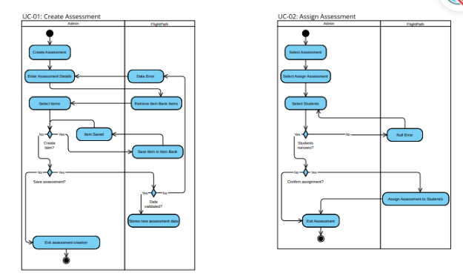
Activity Diagram Link﷟

Use Case Name: Create Assessment

Use Case ID | UC-01
Actors | Admin
Description | Enables admins to create new assessments.
Preconditions | Admin must be logged in and have access to the system with sufficient permissions.
Basic Flow | - Admin selects “Create Assessment”.  - Admin enters details such as title, type, skill coverage, CEFR alignment, learning pathway, and other parameters.  - System retrieves items from the database.  - Admin selects items.  - Admin confirms and saves the assessment.  - System validates and stores assessment data.
Postconditions | - A new assessment is added to the database and ready for assignment to students.  - The action is logged.
Alternative Flows | Step 4a  - Admin creates new item with its own parameters.  - Item saves in the item bank, which can now be selected.  - Go back to Step 4 of Basic Flow.  Anytime  - Admin cancels the creation process.
Assumptions | - The system is online and accessible.  - The item bank is populated.
Exceptions | - Validation fails (e.g. missing or invalid parameters)

Use Case Name: Assign Assessment
Use Case ID | UC-02
Actors | Admin
Description | Allow an admin to assign a specific assessment to a student or a group of students.
Preconditions | The admin must be logged in and have sufficient permissions.
Basic Flow | - The admin selects an assessment.  - The admin selects the "Assign Assessment" option.  - The admin selects a student or group of students.  - The admin confirms the assignment.  - The system assigns the assessment to the student.
Postconditions | - The assessment is assigned to the student(s).  - The action is logged.
Assumptions | - There are active assessments available in the system.  - There are registered students in the system.
Exceptions | - No active assessments are available.  - The selected student does not exist.

Use Case Name: Perform Assessment
Use Case ID | UC-03
Actors | Student, Admin
Description | Allows the student to take an English assessment that measures proficiency and CEFR level with three different types of assessment: Placement, Speaking, and Writing. Allows the admin to test/verify the assessment.
Preconditions | The user is logged in and has access to the UpsWing! Platform
Basic Flow | - User selects “Perform Assessment” option.  - System retrieves assigned assessments.  - Student chooses which assessment to perform.  (Note: All three paths are mutually exclusive)  If the assessment type is “Placement”:  - System initializes placement assessment.  - System sends an assessment item.  - User answers the assessment item.  - System processes the answer.  - System checks if completion criteria are met (“max items reached” or “ability estimate stable”). System automatically completes the assessment.  - Else, system selects the next item and jumps back to 4a.  If the assessment type is “Writing”:  - System initializes writing assessment.  - System sends all assessment items.  - User types written answers.  - User submits the answers.  - System processes the answers.  If the assessment type is “Speaking”:  - System initializes speaking assessment.  - System sends all assessment items.  - User speaks each answer into the microphone.  - User submits the answers.  - System processes the answers.  All branches merge:  - System stores results and sends a completion message.
Postconditions | - Student’s assessment responses and assessment results are saved  - Results are ready for recommendation generation.  - The action is logged.
Alternative Flows | If the user exits mid-assessment:  - Student exits mid-assessment.  - System saves the state automatically.  - Student can resume or restart the assessment. (return to Step 3a/3b/3c of Basic Flow)  From Step 5c -> Step 5d:  - User re-records the audio response. (return to Step 5c of Basic Flow)
Assumptions | - The user has a basic understanding of how to answer items online.  - The user has a working microphone for the “Speaking” type of assessment.  - The system is online and accessible.  - The user has a stable internet connection, especially for submitting "Speaking" answers.
Exceptions | - System fails to detect a working microphone for the “Speaking” assessment.  - User’s internet connection fails during submission of the assessment.  - Assessment items fail to load.  - The “Speaking” or “Writing” submission fails (e.g., file upload error, timeout).

Use Case Name: Update Assessment
Use Case ID | UC-04
Actors | Admin
Description | Allows the admin to modify assessment details or replace test items.
Preconditions | Admin must be logged in and have access to the system with sufficient permissions.
Basic Flow | - Admin selects an existing assessment.  - System retrieves assessment data.  - Admin clicks the Edit button.  - Admin modifies fields (title, difficulty, item set, other parameters).  - Admin saves the changes.  - System validates and updates assessment data.
Postconditions | - Assessment record updated.  - The action is logged.
Alternative Flows | Step 5a.  - Admin selects “Cancel” and discard any changes.
Assumptions | - The system is online and accessible.  - The assessment being updated is not currently in-progress by any students.
Exceptions | - Validation fails on modified fields.  - Admin attempts to edit an assessment that is actively in-use.  - The selected assessment does not exist.

Use Case Name: Archive Assessment
Use Case ID | UC-05
Actors | Admin
Description | Enables admins to remove outdated assessments from active use without deletion.
Preconditions | Admin must be logged in and have access to the system with sufficient permissions.
Basic Flow | - Admin selects an existing assessment.  - Admin clicks the Archive button.  - System prompts confirmation.  - Admin confirms action.  - System validates assessment.  - System archives the updates the status as Archived.
Postconditions | - Assessment is marked as Archived and hidden from active lists.  - The action is logged.
Assumptions | - The assessment is outdated, not in use.  - The system is online and accessible.
Exceptions | - Admin attempts to archive an assessment that is assigned or currently in-use.

Use Case Name: Review Assessment History
Use Case ID | UC-06
Actors | All users
Description | Allows students, admins, and tutors to review a record of assessments of a specific student.
Preconditions | The user is logged in and has access to the UpsWing! platform
Basic Flow | Student  - Student selects “Assessment History”.  - System retrieves records.  - Student applies filters and sorts.  - Student reviews History and clicks on a specific Assessment.  - System sends details about the Assessment.
Postconditions | - Assessment history file was reviewed.  - The action is logged.
Alternative Flow | If the user is Admin or Tutor:  - The user selects a Student.  - Go to Basic Flow Step 1.
Assumptions | - The student has existing history to review.
Exceptions | - No assessment history is found for the student.

Use Case Name: Export Assessment History
Use Case ID | UC-07
Actors | All users
Description | Allows students, admins, and tutors to export a record of assessments of a specific student.
Preconditions | The user is logged in and has access to the UpsWing! platform
Basic Flow | Student  - Student selects “Assessment History”.  - System retrieves records.  - Student applies filters.  - Student clicks Export.  - System generates file and downloads to local storage.
Postconditions | - Assessment history file is downloaded (CSV or PDF).  - The action is logged.
Alternative Flow | If the user is Admin or Tutor:  - The user selects a Student.  - Go to Basic Flow Step 1.
Assumptions | - The student has existing history to download.  - The user’s device has software capable of reading the file.
Exceptions | - No history found.  - File generation fails.  - File download fails.

Use Case Name: Generate Recommendation
Use Case ID | UC-08
Actors | Student, Admin
Description | Generates tailored recommendations for students based on the results of their assessment. Allows admin to manually trigger the process.
Preconditions | - The user is logged in and has access to the UpsWing! platform  - The student completes an assessment.
Basic Flow | Student  - System automatically sends results to the recommendation engine.  - System analyzes results and generates recommendations.  - System stores recommendations for reviewing.
Postconditions | - Recommendations are generated and stored.  - The action is logged.
Alternative Flow | If the user is Admin:  - Admin selects a Student.  - Admin selects “Assessment History”.  - Admin selects a specific assessment.  - Admin clicks “Generate Recommendations” based on configs.  - System generates recommendations.
Assumptions | - The recommendation engine has appropriate configs.  - The assessment results are valid and sufficient for analysis.
Exceptions | - The recommendation engine fails or times out.  - The results provided are missing or corrupted.

Use Case Name: Review Recommendation
Use Case ID | UC-09
Actors | All users
Description | Allows students, admins, and tutors to review recommendations for a specific student.
Preconditions | The user is logged in and has access to the UpsWing! platform
Basic Flow | Student  - Student selects “Assessment History”.  - Student selects a specific assessment.  - System retrieves assessment details.  - Student selects “Recommendations”.  - System retrieves recommendations.  - Students may review details.
Postconditions | - Recommendations have been retrieved.  - The action is logged.
Alternative Flow | If the user is Admin or Tutor:  - The user selects a Student.  - Go to Basic Flow Step 1.
Assumptions | - Recommendations have been generated for the student.
Exceptions | - No recommendations are found for the student.

Use Case Name: Override Recommendation
Use Case ID | UC-10
Actors | Admin
Description | Allows admins to adjust or manually override automatically generated recommendations.
Preconditions | - The admin is logged in and has access to the UpsWing! Platform  - The courses and lessons list is populated.
Basic Flow | - Admin selects a Student.  - Admin selects “Assessment History”.  - Admin selects a specific assessment.  - System retrieves assessment details.  - Admin selects “Recommendations”.  - Admin clicks “Override Recommendations”.  - System sends a list of course/lessons.  - Admin manually inputs recommended items or edits items.  - System replaces the old recommendations with the manual override.
Postconditions | - Manual recommendations replace the automatic recommendations and are stored.  - The action is logged.
Assumptions | - The admin has the pedagogical knowledge to make an appropriate manual recommendation.
Exceptions | - The manual items selected by the admin are invalid, non-existent, or incompatible.  - The admin attempts to save an empty recommendation list.

Use Case Name: Review Real-Time Progress Report
Use Case ID | UC-11
Actors | All users
Description | Allows students, admins, and tutors to view real-time progress report of a specific student.
Preconditions | The user is logged in and has access to the UpsWing! platform
Basic Flow | Student  - Student selects “Progress Report”.  - System retrieves data and generates analytics.  - System sends the analytics and trends.  - Student can view their progress report.  - Student may apply filters to the report.
Postconditions | - The Progress Report page can be viewed and analytics have been generated.  - The action is logged.
Alternative Flow | If the user is Admin or Tutor:  - The user selects a Student.  - Go to Basic Flow Step 1.
Assumptions | - The student has completed at least one assessment and has gotten a result.  - The analytics engine is configured and running.
Exceptions | - Analytics generation fails or times out.  - No data is found for the student.

Use Case Name: Export Progress Report
Use Case ID | UC-12
Actors | All users
Description | Allows students, admins, and tutors to export a real-time progress report of a specific student.
Preconditions | The user is logged in and has access to the UpsWing! platform
Basic Flow | Student  - Student selects “Progress Report”.  - System retrieves data and generates analytics.  - System sends the analytics and trends.  - Student may apply filters to the report.  - Student clicks Export.  - System generates file and downloads to local storage.
Postconditions | - Progress Report file is downloaded (CSV or PDF).  - The action is logged.
Alternative Flow | If the user is Admin or Tutor:  - The user selects a Student.  - Go to Basic Flow Step 1.
Assumptions | - The student has completed at least one assessment and has gotten a result.  - The analytics engine is configured and running.
Exceptions | - Analytics generation fails or times out.  - No data is found for the student.  - File generation fails.  - File download fails.

FIGURE XV: OPENPROJECT BUDGETS 1.0
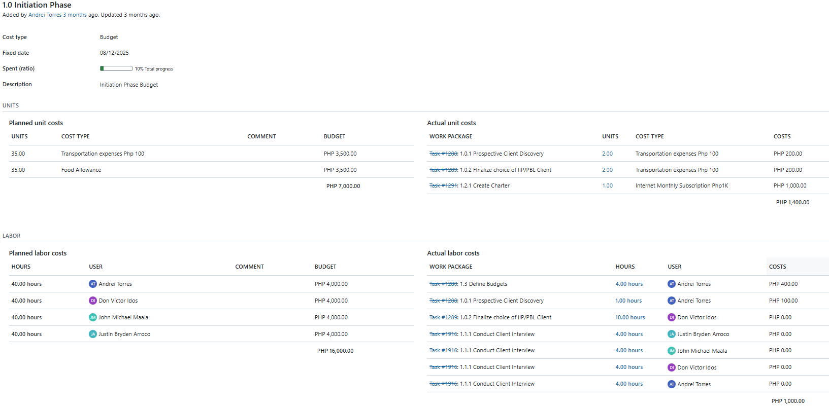
|Link|

FIGURE XVI: OPENPROJECT BUDGETS 2.0

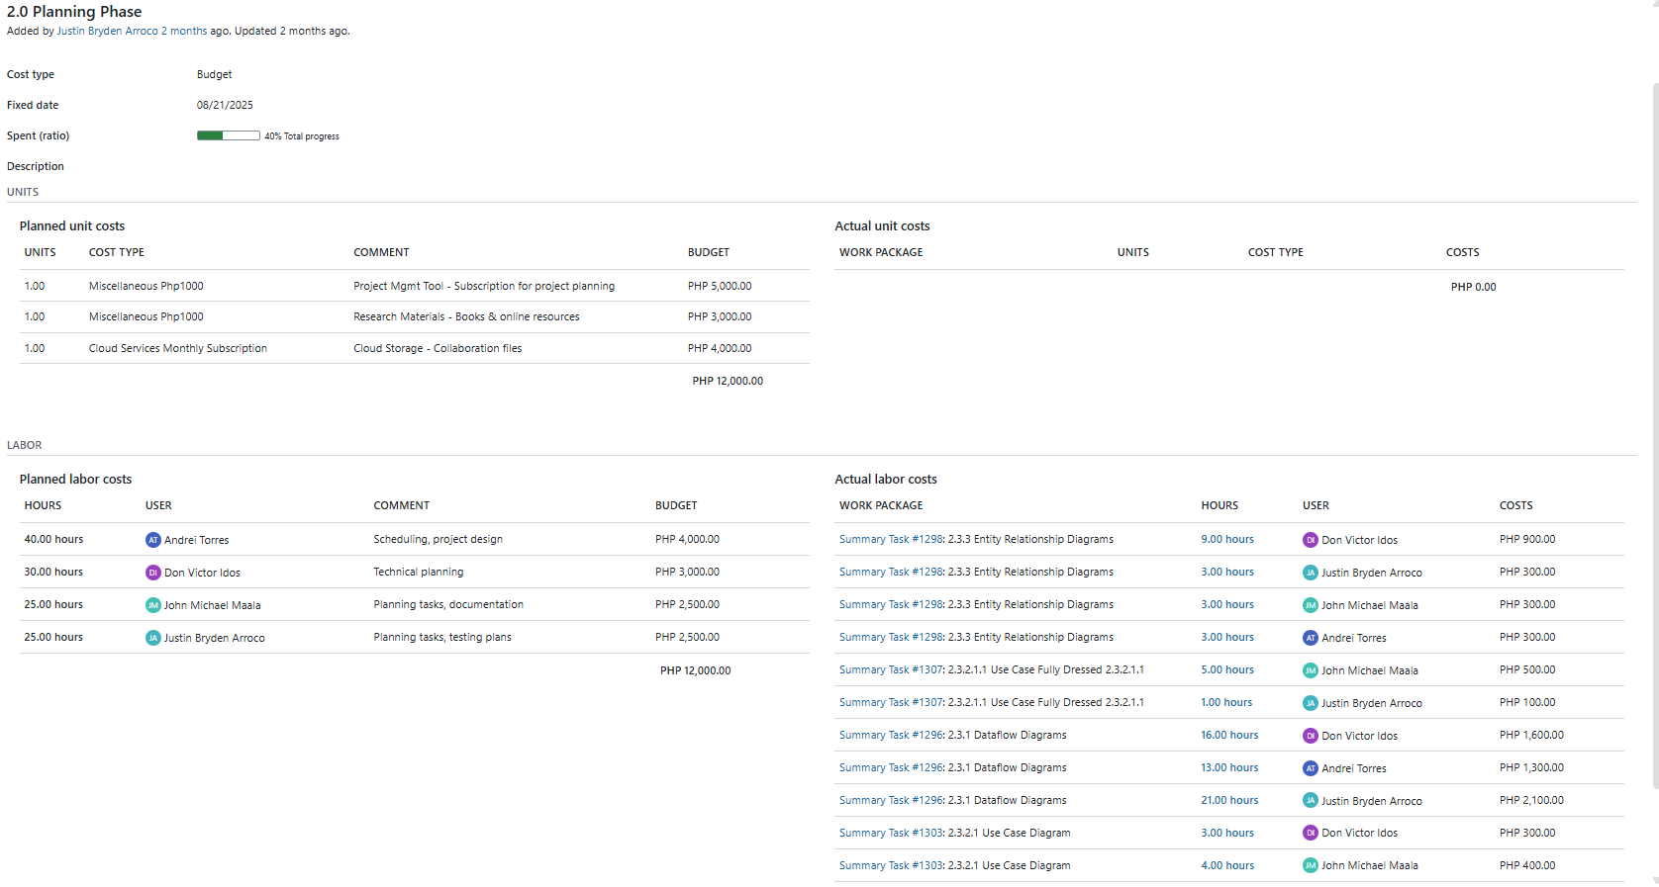
|Link|

FIGURE XVII: OPENPROJECT BUDGETS 3.0
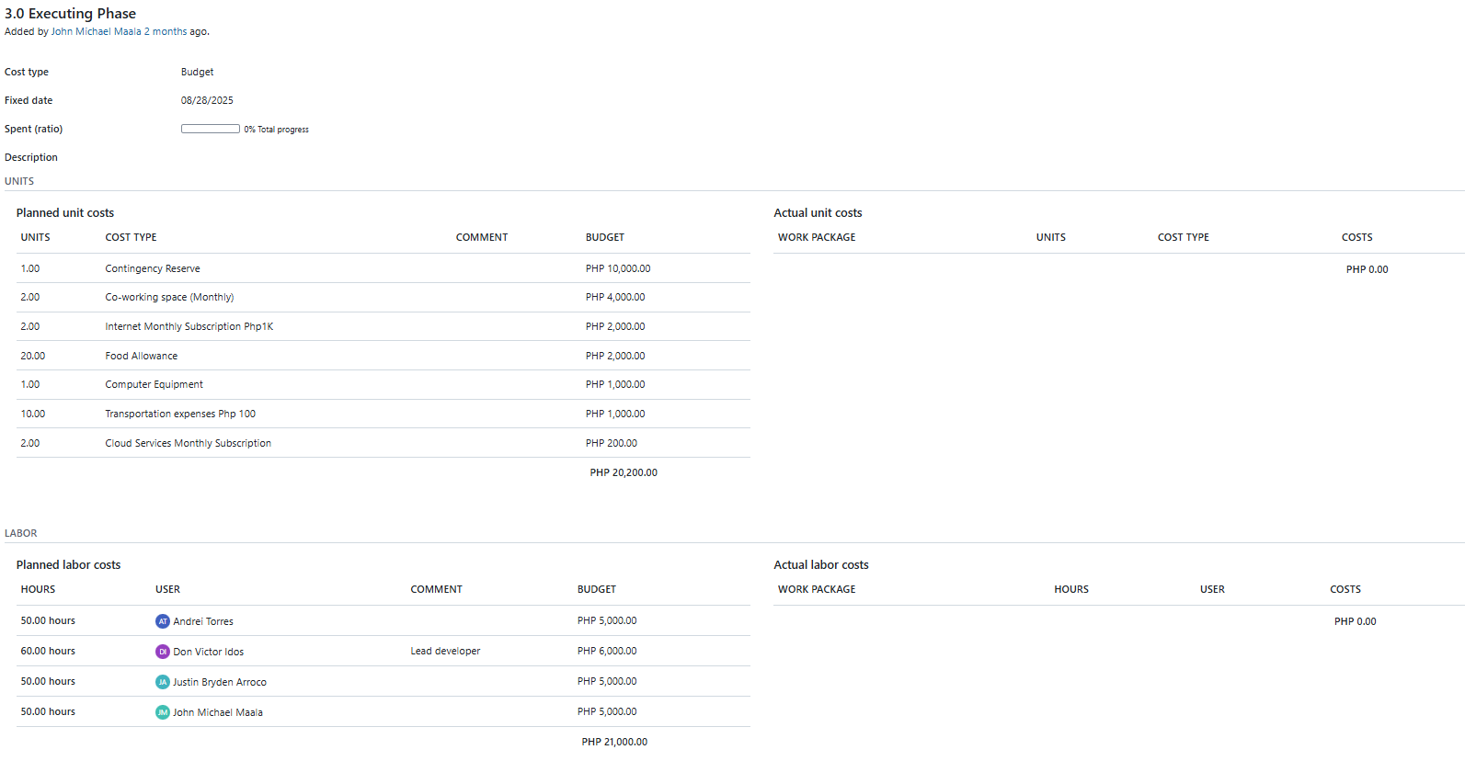
|Link|

FIGURE XVIII: OPENPROJECT BUDGETS 4.0
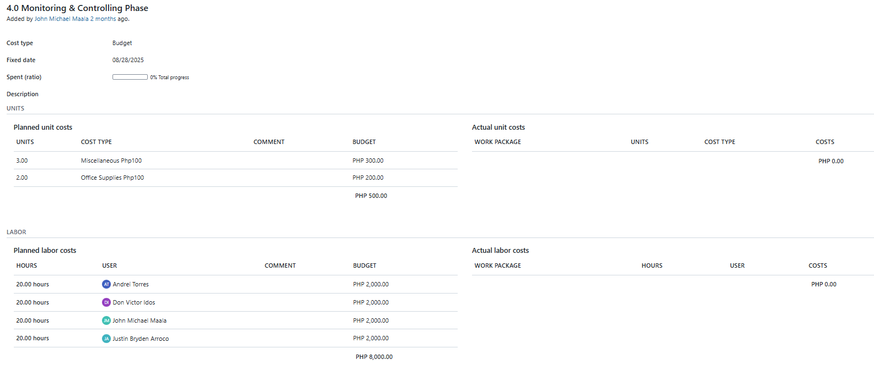
|Link|

FIGURE XIX: OPENPROJECT BUDGETS 5.0
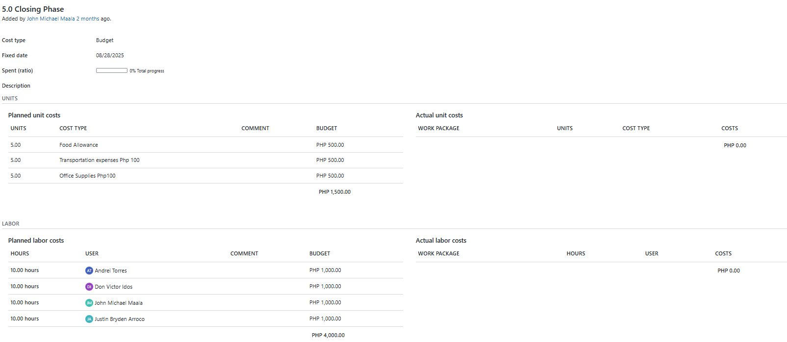
|Link|

FIGURE XX: OPENPROJECT ROADMAP 0.0
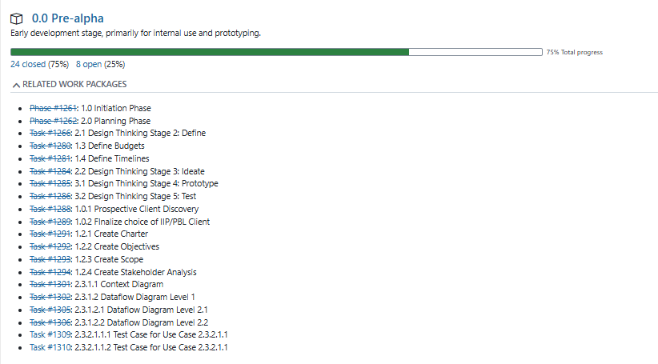
|Link|

FIGURE XX: OPENPROJECT ROADMAP 0.10
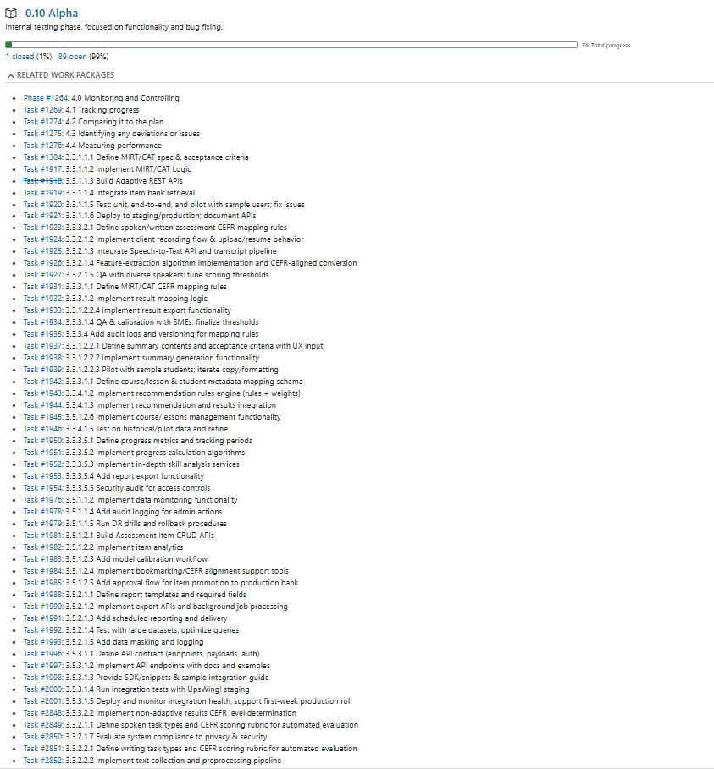
|Link|

FIGURE XXI: OPENPROJECT ROADMAP 0.20
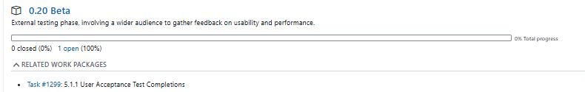
|Link|

FIGURE XXII: OPENPROJECT WORK PACKAGES

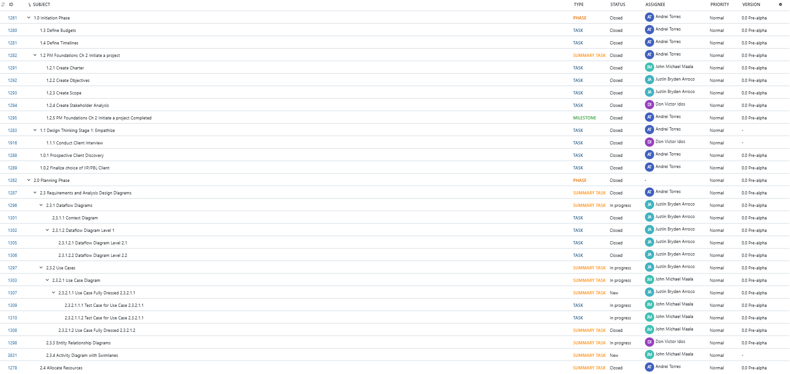
|Link|

FIGURE XXIII: OPENPROJECT WORK PACKAGES II
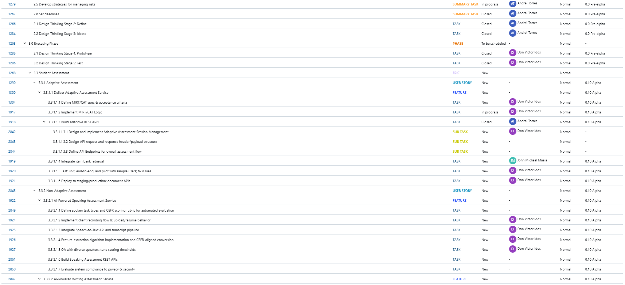

FIGURE XXIV: OPENPROJECT WORK PACKAGES III
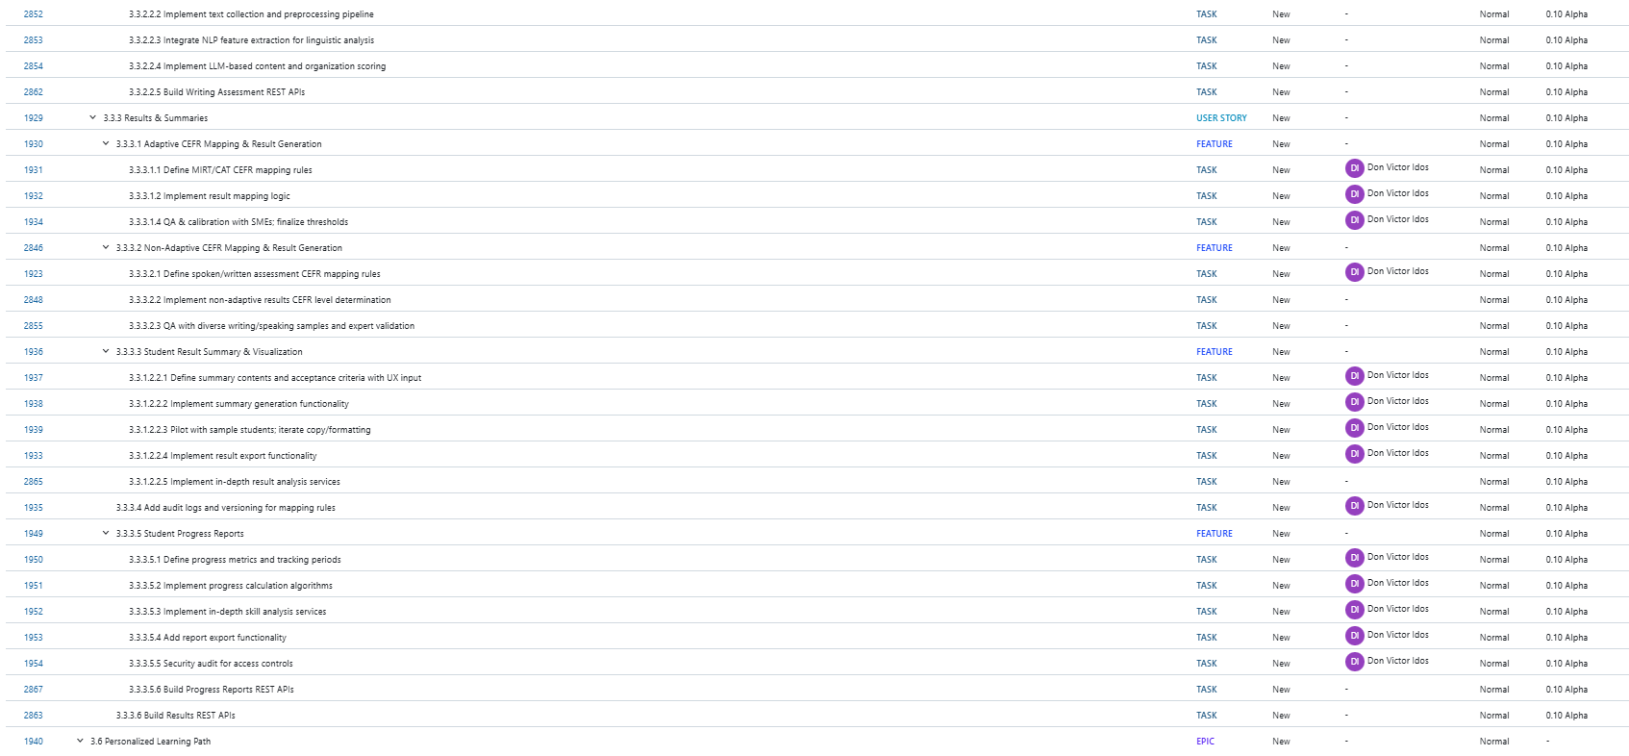
FIGURE XXV: OPENPROJECT WORK PACKAGES IV
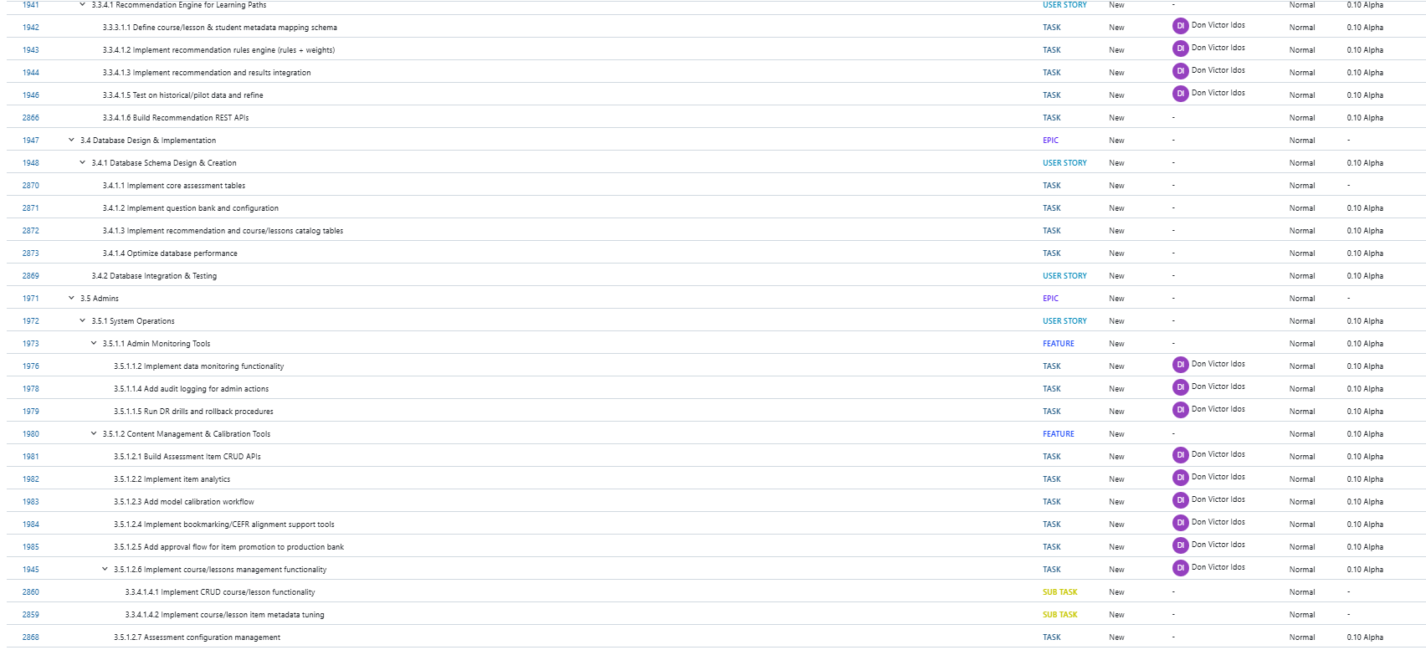
FIGURE XXV: OPENPROJECT WORK PACKAGES V
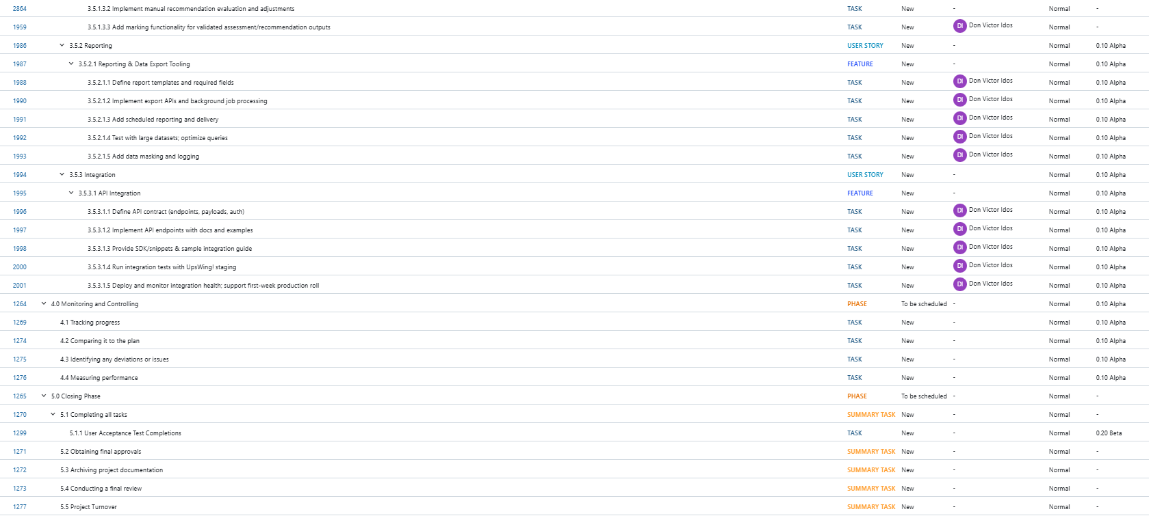

FIGURE XXV: OPENPROJECT BACKLOGS
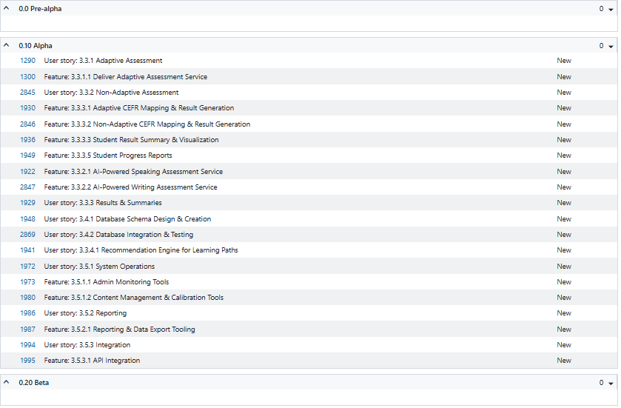
|Link|

FIGURE XXVI: OPENPROJECT BOARD
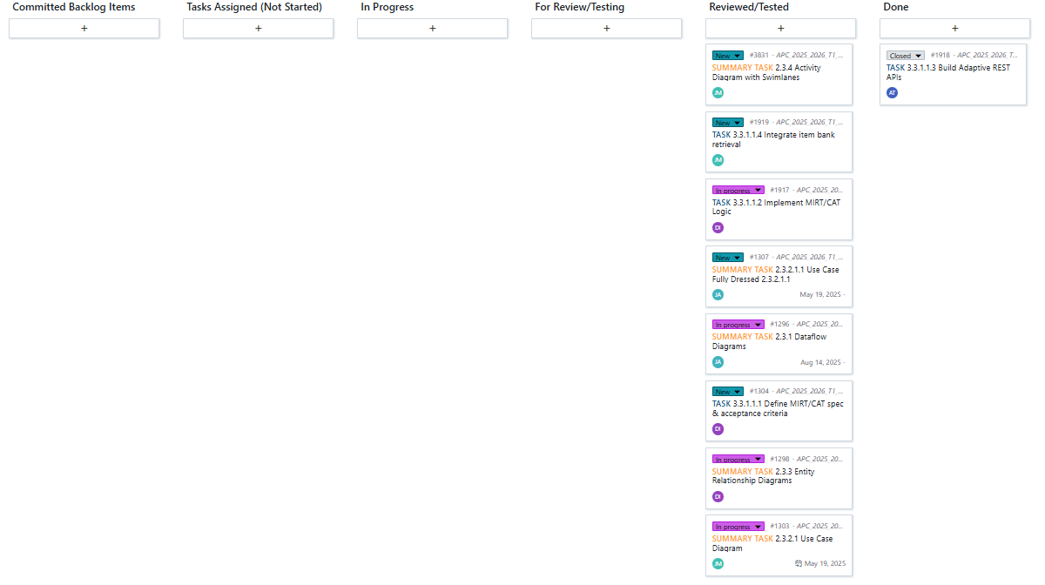
|Link|

FIGURE XXVII: OPENPROJECT GANTT CHART I
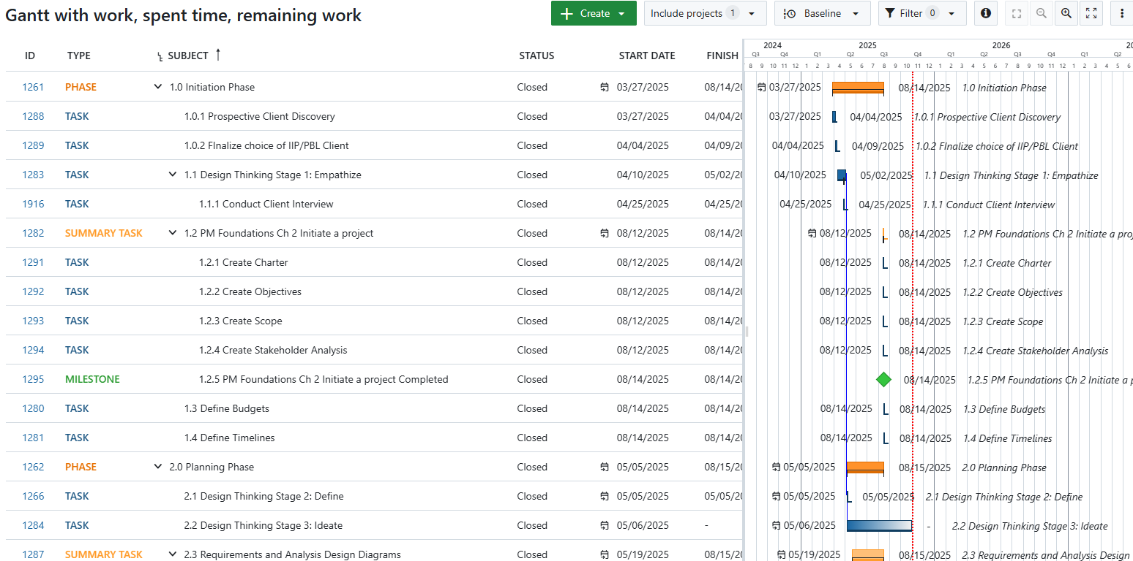
|Link|

FIGURE XXVII: OPENPROJECT GANTT CHART II
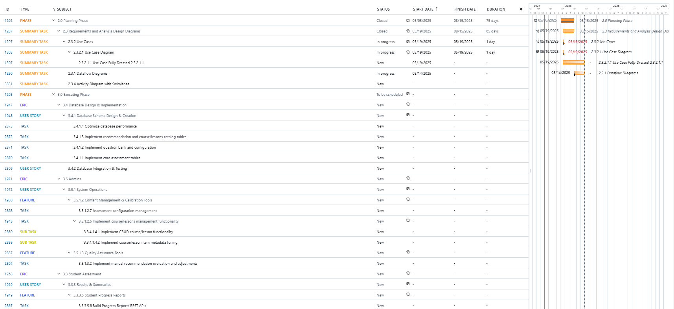

Openproject Team Site URL Link
Github APC-SoCIT project repository URL Link

